**Problem Solving Worksheet**

**Selected Game: __d6_____________________**

**SECTION I – BIG PICTURE**

**Step 1: Describe “the system”**

**Design interpretation.** Identify the system by interpreting the information provided by the game/design. Draw a diagram that best represents the system(s) at work in the game. Feel free to use labels for variables and notes to help illustrate the system.

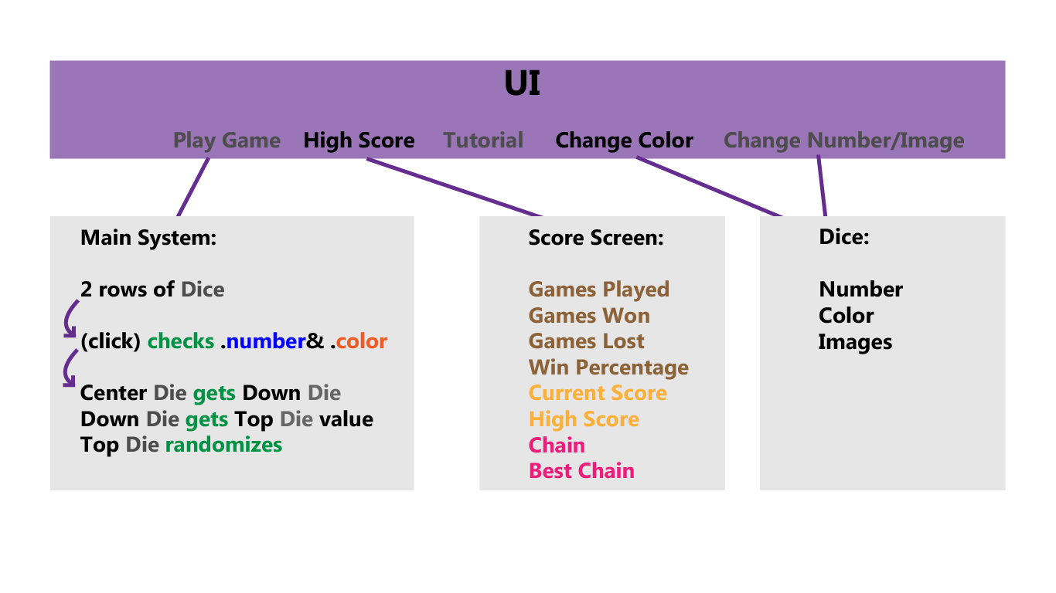

**Step 2: List of Knowns -** List what is known about the system and, if possible, identify the knowledge needed to understand (and eventually) solve it. List subsystems, known logic, conditions, variables, etc.

|  |
| --- |
| **Knowns** |
| - The Dice can be prefab object since every die shares the same type of data (color& number). |
| - When conditions met, the move is valid, score will update and check if it’s high score. |
| - Consecutive valid moves will update chain counter. |
| - Chain counter will check if it’s best chain. |
| - When there are no valid moves, player can reset the current die, and player loses one health point. |
| - Game ends when player has 0 health point. |
| - If game ended with 50 score points or above, player wins. |
| - If game ended with below 50 score points, player loses. |
| - There should be a place to store score screen value (see the image above) |
|  |
|  |
|  |

**Step 3: List Unknowns** - List anything you do not fully understand about the system.

|  |  |
| --- | --- |
| **Unknowns** | **Identify the knowledge, strategies, ideas, research required for turning unknowns into knowns** |
| Passing values of prefab objects | Assign objects with a tag/mark/bool to call upon |
|  |  |
| Storing/Displaying Scores | Reload scenes will lose script values |
|  |  |
|  |  |
|  |  |
|  |  |
|  |  |

**SECTION II – DIVIDE AND CONQUER**

**Step 1: List and describe the subsystems**

**Identify and list the “sub-systems” within the game. Describe each subsystem**

|  |  |
| --- | --- |
| Subsystems | Description |
| 1 Main Loop | Validates player move and passing scores. |
|  | Manages dice. |
| 2 Dice | Contains number and color. |
|  | Addressable. |
| 3 Score Screen | Stores scores, chains, win/loss. |
|  | Displays stored values. |
|  |  |

**Step 2: Design interpretation.** Draw diagrams to help describe each subsystem in detail. Feel free to use labels for variables and notes to help illustrate the system. Feel free to use a sketch book and attach your sketches to the worksheet.



**Step 3: List Knowns -** List what is known about each sub-system, and identify the knowledge needed to understand (and eventually) solve them. List known logic, conditions, variables, etc. Be as specific as possible, listing the Unity tools or C# classes/methods that might help in solving each subsystem.

|  |
| --- |
| **Knowns** |
| Validating Player moves. Compare current number& color with selected number& color, then run function. |
|  |
| End game logic. Check health point when clearing the center die. |
|  |
| Reset button logic. Randomize all Dice Prefabs and Current Score. |
|  |
| Score System. Stores variables for further use. |
|  |
| Menu Screen. Navigates to other screens. |
|  |
| Tutorial Screen. Contains Text/ Image. |
|  |
| Dice Prefab. Contains Number and Color. |
|  |
|  |
|  |
|  |
|  |
|  |

**Step 4: List Unknowns** - List anything you do not fully understand about the sub-systems. These items can include logic, specific implementation logic within the game engine or with the scripting language.

|  |  |
| --- | --- |
| **Unknowns** | **Strategies / Ideas / Research - Identify the knowledge required for turning unknowns into knowns** |
| How to locate an object in an array | 1. Ignore it and use colliders. |
|  | 1. Assign every object with a tag |
|  | 1. Use arrayList instead |
|  | 1. Use raycast |
|  |  |
| How to retain data when switching scenes | 1. Use dontdestroyobject |
|  |  |
|  |  |
|  |  |
|  |  |
|  |  |
|  |  |
|  |  |
|  |  |
|  |  |
|  |  |

**Step 5: Break the sub-systems down into objects**

Identify and illustrate the game objects that make up each sub-system. Associate variables, conditions, logic with each game object. Use arrows or notes to describe how objects interact or communicate with other objects or sub-systems. **SECTION III – PROBLEM SOLVING LOG**

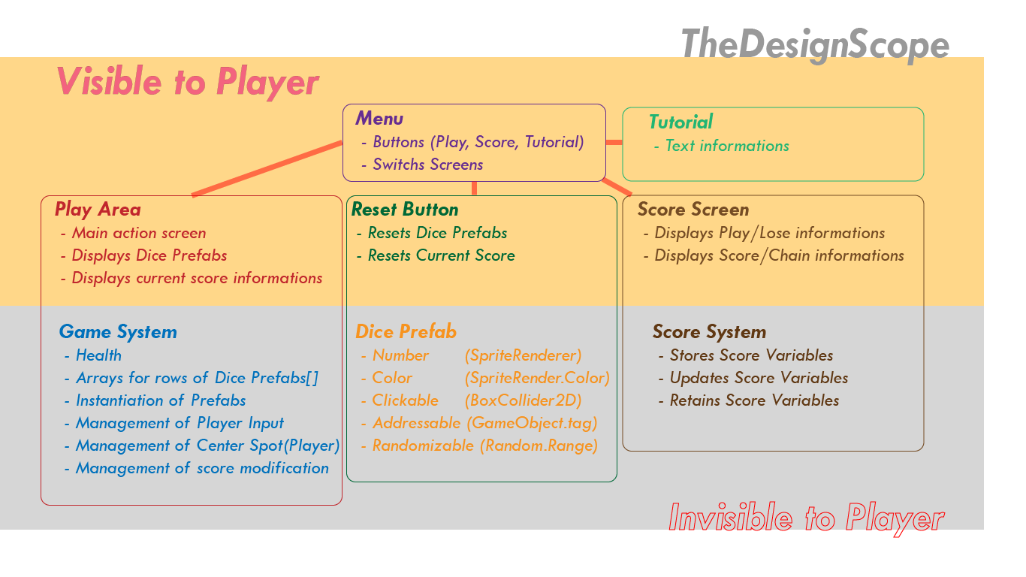

Describe how unknowns became knowns. What were the strategies you used to understand the unknowns? List all of the steps that helped further your understanding of the problem through research or carrying out your plan. If a plan needed to be revised, describe the process and reasons why. Be detailed and specific. Your goal is to record your problem-solving process.



Asd

**More below

|  |  |
| --- | --- |
| **Challenge / problem / strategy** | **Solution / conclusion / discovery / revision** |
|  |  |
| Problem 2: |  |
| How to instantiate objects with array | 1. Create array |
|  | 1. Use for-loop |
|  |  |
| Problem 3: |  |
| How to create addressable array objects | While instantiating the prefab object with for-loop, assign an integer |
| (finding the index number of an array object) | variable with the for-loop local variable to address them by index number |
|  | * I should’ve used arrayList, but time didn’t allow me to learn how to use it. |
|  | I also tired overlapping 2 colliders, but only 1 collider would register and |
|  | that collider is selected randomly (?). I theorize the z-axis influences the |
|  | outcome, but I decided to use variable for a more reliable system. |
|  |  |
|  |  |
| Problem 4: |  |
| Top row dice could not shuffle | By discovering I can assign variables during instantiation, I assigned |
|  | booleans for checking the row of dice. I then can create interactions with |
|  | a whole row of dice. |
|  |  |
| Problem 5: |  |
| Array out of range error | Forgot to increase the array length of diceNumber and colorNumber after |
|  | adding a 7th element. |
|  | The 7th element is for the center die to display an empty state. |
|  |  |
| Problem 6: |  |
| How to retain data when switching scenes | Use Object.DontDestroyOnLoad() |
|  | However, if this object can’t be destroyed, reloading scene would create |
|  | duplicates. I did not find a solution, so I decided to create every screen in |
|  | the same surface and move the camera when the button is clicked. |
|  | Also I used GameObject.SetActive() to enable/disable UI objects. |
|  |  |
| Problem 7: |  |
| “Game Played” Counter is increasing by its own | The Reset button has an extra function to increase “Game Played” integer. |
|  |  |
| Problem 8: |  |
| Text elements would be invisible outside | The text would display within the UI gameObject. |
| the UI gameObject | Still don’t understand why. |
|  |  |
|  |  |
|  |  |
|  |  |
|  |  |
|  |  |
|  |  |
|  |  |
|  |  |
|  |  |
|  |  |
|  |  |
|  |  |
|  |  |
|  |  |
|  |  |
|  |  |
|  |  |
|  |  |
|  |  |
|  |  |
|  |  |
|  |  |
|  |  |
|  |  |